**Audit Viewer Technical Document**

**Objective:**

To build a component, which will track record/field changes and records the same in the database for Auditing.

**Prerequisites:**

|  |  |  |
| --- | --- | --- |
| **Database** | **Tables** | **Stored Procedures** |
| Exchange | Audit_History  Audit_Modules | usp_InsertAuditData |

**Class Structure:**

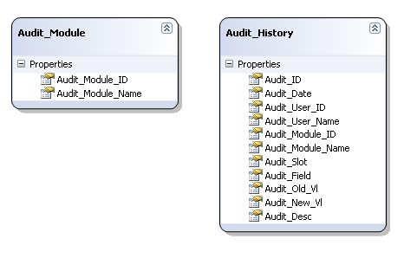

**Source Code Path:**

\starteam\projects\Bally MultiConnect\BMC 11.5\Coding\Source\Site Controller\AuditViewer\ AuditViewer.sln

**How to Consume:**

Add reference to Audit.Business.dll and Audit.Transport.dll

**Add Namespace in code:**

using Audit.BusinessClasses;

using Audit.Transport;

**Code for Encryption:**

//Calling Audit Method

Audit_History AH = new Audit_History();

//Populate required Values

AH.Audit_Module_ID = (int)ModuleID.Enrollment; //enum available in Audit.Transport

AH.Audit_Module_Name = ModuleName.Enrollment.ToString(); //enum available in Audit.Transport

AH.Audit_Screen_Name = "Enrollment|MachineInstallation";

AH.Audit_Desc = "Machine Installed";

AH.Audit_Operation_Type = OperationType.ADD.ToString();

AH.Audit_Field = "Position";

AH.Audit_New_Vl = objPosDetails.Position; //object available from page

AH.Audit_Slot = objPosDetails.AssetNo; //object available from page

AuditViewerBusiness AVB = new AuditViewerBusiness(oCommonUtilities.CreateInstance().GetConnectionString());

int nReturnValue;

nReturnValue = AVB.InsertAuditData(AH);

**Deliverables:**

* Audit.Business.dll
* Audit.Transport.dll
* Audit.DBBuilder.dll